DOCUMENT TITLE

(bold, Calibri, 20 pt., centered, all caps, double-spaced)

By (Calibri, 12 pt., centered, double-spaced)

Names of Team Members Name

Name Name Name

(Calibri, 12 pt., centered, list of names single- spaced, in column format, double-spaced before next section)

Submitted to Dr. Engineering Professor and Dr. Tech Com Professor of Embry-Riddle Aeronautical University

in Partial Fulfillment of the Course Requirements for AE 427 and COM 420/430

(Calibri, 12 pt., centered, single- spaced within block of text, double- spaced after block

(Calibri, 12 pt., centered, double-space or triple-space between date and logo, express date as: Month ##, Year

Date

of text, change to reflect engineering professor’s name and course name/number)



(Team logo and team name, centered)

**A Note on How to Use the COM 420/430 Style Guide**

A variety of features are built into the COM 420/430 Style Guide that are designed to help you better design and write engineering documents, including:

* Red typography: used to define document formatting related to headings, art, typography, spacing, alignment, and balance
* Gray typography: used for Lorem ipsum filler text and sample text used to help you see the format of the document and to illustrate document design concepts. (In the documents you create, do not use gray text.)
* Text boxes (like this one): used to offer explanations and considerations you should think about as you write certain sections of the document
* Style Guide Format: models and explains what your document should look like from a formatting point-of-view

**ABSTRACT** (bold, Calibri, 16 pt., left aligned, all caps)

12 pt. full line space between heading and text

Lorem ipsum dolor sit amet, consectetuer adipiscing elit. Maecenas porttitor congue massa. Fusce posuere, magna sed pulvinar ultricies, purus lectus malesuada libero, sit amet commodo magna eros quis urna. Nunc viverra imperdiet enim. Fusce est. Vivamus a tellus. Pellentesque habitant morbi tristique senectus et netus et malesuada fames ac turpis egestas. Proin pharetra nonummy pede. Mauris et orci. Aenean nec lorem. In porttitor. Donec laoreet nonummy augue. Suspendisse dui purus, scelerisque at, vulputate vitae, pretium mattis, nunc. Mauris eget neque at sem venenatis eleifend. Ut nonummy. Fusce aliquet pede non pede. Suspendisse dapibus lorem pellentesque magna. Integer nulla. Donec blandit feugiat ligula. Donec hendrerit, felis et imperdiet euismod, purus ipsum pretium metus, in lacinia nulla nisl eget sapien.

(Times New Roman, 12 pt., block format)

Document Margins are 1” on all sides (top, bottom, left, right)

**What is an abstract?** An abstract is a standalone paragraph (150-250 words) that appears after the title page of your document. It provides readers with a quick overview of your document. The abstract generally includes five parts. First, it begins with a brief statement of the problem or issue you are trying to solve. Second, it describes the research methods used. Third, it offers an overview of your design solution. Fourth, it summarizes your key findings. And fifth, it identifies the conclusions reached.

An abstract should not read like your table of contents. Instead, it should contain specific information and offer just enough detail for your audience to understand the problem, your solution, and key findings. Your reader should understand the gist of your project and the problem you are trying to solve without having to read anything more than the abstract.

In an abstract, avoid using acronyms or referring your audience to specific sections of the document (e.g., sections, figures, tables).

Front Matter page numbers, lower case Roman numerals, centered, bottom of page

**TABLE OF CONTENTS** Table of Contents is auto-generated using the Table of Contents tool in Word. Click on References and then on the Table of Contents tool on the far left of the toolbar.

ABSTRACT ii

LIST OF FIGURES iv

LIST OF TABLES iv

LIST OF NOMENCLATURE v

LIST OF ABBREVIATIONS v

* 1. A-LEVEL HEADING 1
  2. B-Level Heading 1
     1. C-Level Heading 1
     2. Stacking Headings 1
  3. FORMATTING DEFINITIONS 2
  4. Numbers and Words 2
  5. Equations 3
  6. Incorporating Graphics: Figures and Tables 4
     1. Claim + Evidence + Line of Reasoning = Sound Reasoning 5
     2. Formatting Tables that Span More Than One-page 5
     3. Avoiding the Stacking of Graphics 6
     4. Adding Text to Graphics 6
     5. How to Cite Borrowed Graphics 7
  7. TECHNICAL WRITING EXPECTATIONS 8
  8. Address Audience Needs and Establish Credibility 9
     1. The Rhetorical Pyramid 9
     2. Citing Borrowed Information 10
  9. Format with a Focus on Document Design, Readability, and Accessibility 10
  10. Impose Order through Revision 10
  11. Revise and Edit the Document 10
  12. Provide Technical Descriptions Focused on Clarity and Precision 11

1. PRESENTATION SLIDE DECK 11
2. REFERENCES 13
   1. In-text Citations 13
   2. List of References 13
3. ACKNOWLEDGEMENTS 15
4. ATTRIBUTIONS 16

**LIST OF FIGURES** (bold, Calibri, 16 pt., left aligned, all caps)

12 pt. full line space between heading and text

|  |  |
| --- | --- |
| Figure 1.1: Stacked Headings vs. Headings with Clarifying Text……………………………. Figure 2.1: Folded Airplane Inside Canister………………………………………………….. Figure 2.2: Full Aircraft Range and Endurance Parameters………………………………….. Figure 2.3: Deployment System for Flying Fish Aircraft…………………………………….. Figure 2.4: Visualizing Quieter Supersonic Flight…………………………………………… Figure 2.5: Boom’s Overture Supersonic Passenger Jet………………………………………  Figure 3.1: Rhetorical Pyramid……………………………………………………………….. | 2  5  6  7  7  8  9 |

**LIST OF TABLES** (bold, Calibri, 16 pt., left aligned, all caps)

12 pt. full line space between heading and text

|  |  |
| --- | --- |
| Table 2.1: Controls and Sensor Component Mass ……………………………...………..…... Table 2.2: Similitude Parameters and Values………………………………………………… | 4  5 |

Format of List of Figures and List of Tables mimics Table of Contents format with number and name of figure/table followed by a series of dots; page number is right-aligned.

List of Figures and List of Tables can appear on the same page as long as they fit in their entirety on one page. If they do not fit, then dedicate a separate page to each list.

**LIST OF NOMENCLATURE** (bold, Calibri, 16 pt., left aligned, all caps)

12 pt. full line space between heading and text AR = aspect ratio

B = wingspan

C = coefficient

Cp = pressure coefficient

Cx = force coefficient in the x direction Cy = force coefficient in the y direction c = chord

i = time index during navigation

j = waypoint index

K = trailing-edge nondimensional angular deflection rate TE = trailing-edge

α = angle of attack

β = sideslip angle

ε = strain

σ = axial stress

# LIST OF ABBREVIATIONS

|  |  |  |
| --- | --- | --- |
| ALT1 | = | alternate |
| ALT2 | = | altimeter |
| ALT3 | = | altitude |
| AoA | = | angle of attack |
| DAS | = | Dragonfly Aerospace Solutions |
| dia | = | diameter |
| ft | = | feet |
| in. | = | inches |
| ERAU | = | Embry-Riddle Aeronautical University |
| HT | = | horizontal tail |
| lbs | = | pounds |
| len | = | length |
| MSL | = | mean sea level |
| NATO | = | North Atlantic Treaty Organization |
| PETG | = | polyethylene terephthalate glycol |
| RC | = | remote controlled |
| VT | = | vertical tail |

Lists can appear on the same page as long as they fit in their entirety on one page. If they do not fit, then dedicate a separate page to each list.

Definitions of symbols and abbreviations written in lowercase unless definitions identify a proper noun (see DAS, ERAU, and NATO).

Add as many lists as needed (e.g., List of Nomenclature; List of Abbreviations; List of Acronyms; List of Symbols; List of Equations).

* 1. **A-LEVEL HEADING** (Enumerated heading, bold, Calibri, 16 pt., left aligned, all caps)

12 pt. full line space between A-Level Heading and text

Paragraphs have a single purpose—claims are clear and are supported with adequate and convincing evidence followed by a clear line of reasoning. In technical writing, clear communication is critical. Beck, McElwain, and Helbling articulate that “the difference between fair technical writing and sound technical writing is the difference between information that *can be understood* and information that *cannot be misunderstood”* [1]. If you remember just one thing from COM 420/430, at least remember this (hopefully, you’ll remember much more).

12 pt. full line space between paragraphs

Paragraphs address the audience’s needs, purposes, and expectations—providing needed background information, definitions, context, and examples as needed. When using a glossary to define certain words and phrases, format those words and phrases in SMALL CAPS.

12 pt. full line space between paragraph and heading

* 1. **B-Level Heading** (Enumerated heading, bold, Calibri, 14 pt., left aligned)

All paragraphs written in block format (single-spaced throughout the paper, including the References section. There is no indentation at the beginning of paragraphs, but there is one 12 pt. full line space between paragraphs. Paragraphs—Times New Roman, 12 pt. Lorem ipsum dolor sit amet, consectetuer adipiscing elit. Maecenas porttitor congue massa. Fusce posuere, magna sed pulvinar ultricies, purus lectus malesuada libero, sit amet commodo magna eros quis urna.

Aenean nec lorem. In porttitor. Donec laoreet nonummy augue. Suspendisse dui purus, scelerisque at, vulputate vitae, pretium mattis, nunc. Mauris eget neque at sem venenatis eleifend. Ut nonummy. Fusce aliquet pede non pede. Suspendisse dapibus lorem pellentesque magna. Integer nulla.

* + 1. *C-Level Heading* (italics, Calibri, 12 pt., left aligned)

A-, B-, and C-level headings are formatted by typing enumerated portion of heading, tabbing over one tab (1/2” from right margin) and then writing heading text. Lorem ipsum dolor sit amet, consectetuer adipiscing elit. Maecenas porttitor congue massa. Fusce posuere, magna sed pulvinar ultricies, purus lectus malesuada libero, sit amet commodo magna eros quis urna.

Aenean nec lorem. In porttitor. Donec laoreet nonummy augue. Suspendisse dui purus, scelerisque at, vulputate vitae, pretium mattis, nunc. (Use as many subsections as needed for your document.)

*D-Level Heading.* Lorem ipsum dolor sit amet, consectetuer adipiscing elit. Maecenas porttitor congue massa. Fusce posuere, magna sed pulvinar ultricies, purus lectus malesuada libero, sit amet commodo magna eros quis urna. (D-Level Headings appear as paragraph headings, are not ennumerated, and are italicized, Times New Roman, 12 pt., left aligned, followed by a period and a space. The text of the paragraph immediately follows on the same line.)

* + 1. *Stacking Headings*

Headings in technical writing serve three key purposes. First, they help to organize the document by highlighting the main topics and signaling topic changes. Second, they help to orient the

Document page numbers: use Arabic numerals, centered, bottom of page, Times New Roman, 12 pt.

reader as they move throughout the document. Third, they make information inside the document more accessible to the reader. For these reasons, it is important not to stack headings as this practice can slow down and limit an audience’s understanding of information (see Fig. 1.1).

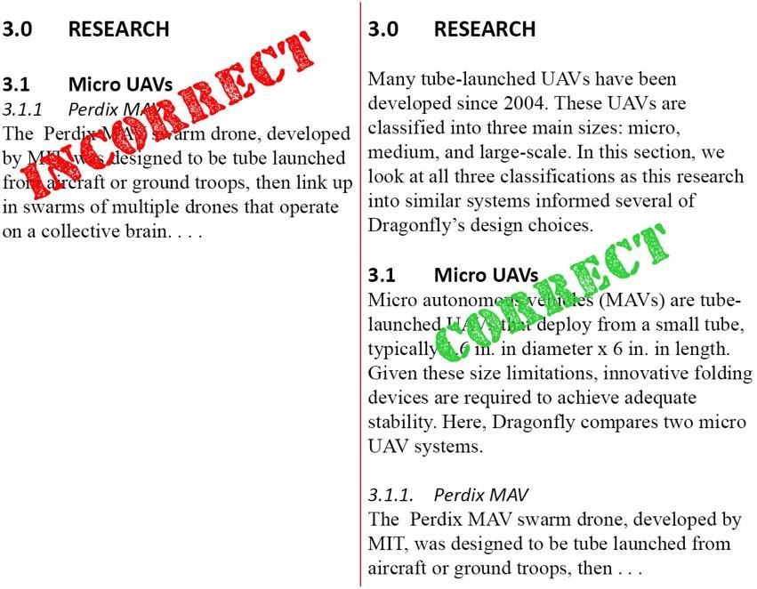

**Figure 1.1: Stacked Headings vs. Headings with Clarifying Text**

The leftmost sample in *Figure 1.1* illustrates what stacked headings most often look like. Rather than contextualizing the different sections of the document, the author skips through A- and B- level headings before settling down with clarifying context in the C-level heading. On the other hand, the rightmost sample offers key background and definitional information in the A- and B- level headings that help frame and contextualize information found in the C-level heading.

# FORMATTING DEFINITIONS

Computer programs like Google Docs and online versions of Word make it easy to collaborate on a document. However, when it comes time to focus of final formatting, it is best to do this work in a desktop version of Word where more formatting tools are available. Additionally, the desktop version of Word tends to be less glitchy than its online sibling or Google Docs.

## Numbers and Words

Combining numbers and text can sometimes be confusing. The rule for when to spell out a number and when to simply write the number depends on the number and on the situation. Some of the most common number/word scenarios are explained here.

*Spell out numbers zero through nine when they are not attached to a measurement. Use numerals when numbers are attached to a measurement*

* The team bought nine servos.
* Dragonfly Aerospace Solutions purchased 12 team polos.
* The drone weighs 9 lbs. fully loaded.
* For this scale, a tube size of 4.875 in. (dia) x 32 in. (len) is common.

*For numbers 10 and up, write the number.*

* The robot required 16 servos to properly articulate each of the jointed legs.

*When starting a sentence with a number—always spell it out.*

* Twenty-two inches span the distance between the center of gravity and the vertical tail.

*Express fractions as numerals when they are written with whole numbers. Spell out fractions when they are expressed without a whole number. Always write decimal numbers as numerals.* (For formatting continuity, it is a good practice to either use fractions or decimals and stick to this formatting choice throughout the document.)

* 3 ½
* One-fourth, seven-eighths
* 3.65 km

When using numbers and units of measurement, add a space between the number and the abbreviated unit. For example, 91 lbs. is easier to read than 91lbs. as 91lbs. could be misinterpretted as 911 pounds by the inattentive or casual reader. In this same vein, the abbreviation for inches is in. to avoid confusing the abbreviation with the word *in*. For example, the sentence *The CG was then moved to 5.37 in aft of the nose.* is not immediately clear as *in aft* have a tendency to run together. By abbreviating inches as in., the sentence becomes more immediately clear. *The CG was then moved to 5.37 in. aft of the nose.*

## Equations

Like other elements of technical writing, equations require specific formatting criteria. This Style Guide presents two formats for incorporating equations. The first format is the recommended AIAA (American Institute of Aeronautics and Astronautics) formatting for equations. According to AIAA, “equations are centered and numbered consecutively, with equation numbers in parenthesis flush right, as in Eq. (1). Insert a blank line on either side of the equation.

12 pt. full line space before equation

12 pt. full line space after equation

𝑙𝑣 𝛶

𝐵 =

𝑏 𝐶𝐿

(1)

“Be sure that the symbols in your equation are defined before the equation appears, or immediately following. Italicize symbols” [2]. Where Υ is the dihedral of the wing in degrees, 𝑙𝑣 is the vertical tail moment arm, b is wingspan, and 𝐶𝐿 is the lift coefficient. To be considered spirally stable, B must be greater than five. Since the current design of Flying Fish does not incorporate dihedral, the corresponding Blaine Rawdon parameter becomes zero.

The second format is one that is often encountered in textbooks. For example, the following equation was used to calculate the cost of the rocket:

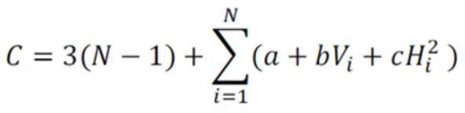

Where

12 pt. full line space between line that defines equation variables

*C* = cost in U.S. dollars

*N* = number of separately printed parts in the rocket assembly *Vi =* solid volume of printed material in Part *i* in cubic inches *Hi =* printed height of Part *i* in inches

And

*a*, *b*, and *c* are material dependent coefficients per *Table 2.X* (though not presented here, *Table*

*2.X* would include the referenced information.

How you treat and format equations in your documents will be defined by the engineering professor in the capstone course.

## Incorporating Graphics: Figures and Tables

When incorporating graphics (tables and figures) into a document, always use the three “I’s”— *introduce*, *insert*, and *interpret*. When introducing a graphic, use either a direct introduction or an indirect introduction in the paragraph before the table or graphic.

* *Table 3.1* summarizes XYZ. (Direct Introduction)
* The mass of the system was broken down by components in order to verify none of the controls and sensor components exceeded 40 g (see *Table 3.1*). (Indirect Introduction)

Table and figure numbers map to the A-Level heading and are numbered independently of each other. In other words, three tables under the A-Level heading would be numbered Table 2.1, Table 2.2, and Table 2.3. Any figures in that same section would be numbered Figure 2.1, Figure 2.2, and so forth. *Table 2.1* (italicized) summarizes XYZ. (table introduced)

12 pt. full line space between text and table/figure

**Table 2.1: Controls and Sensor Component Mass** (bold, Calibri, 11 pt, centered above table)

|  |  |
| --- | --- |
| **Component** (bold, Calibri, 11 pt., white, Fill RGB 170, 107, 164 | **Mass (g)** |
| BeagleBone Black (Calibri, 11 pt., black, left-aligned) | 39.56 |
| Adafruit IMU (Text-centric or text heavy content = left aligned colu | mns) 3.25 (Number-centri |
| Sharp Long Range Proximity Sensor | 10.54 short-text conte |
| Sharp Short Range Proximity Sensor | 6.80 centered = cent |
| Wires and Solder | 10.0 aligned column |
| (bold, Calibri, 11 pt., right-aligned) **Total** | **70.15** |

c or nt er s)

12 pt. full line space between table/figure and text

(**Total** bolded, centered)

*Table 2.1* (italicized) summarizes the total mass to be above Dragonfly’s projections but below the minimum requirements set forth by NASA. Dragonfly, during their preliminary research of the subsystem, estimated a total mass of 65 g. NASA’s requirement, however, states the Controls and Sensor suite must weigh less than 75 g. As long as the miscellaneous wires and solder do not exceed a total mass of 10 g, the subsystem should meet the requirement. (table interpreted)

Note on Tables: All text centered vertically



When interpreting a graphic, explain the significance of the data, connect the dots, and clarify the key takeaways for your audience. Consider what it is you want your audience to understand from the data.

inside cells

* + 1. *Claim + Evidence + Line of Reasoning = Sound Reasoning*

Like tables, figures must be introduced, inserted, and interpreted. Before introducing any graphic, state your claim. Once you have made your claim, back it up with evidence (see *Fig.*

*2.1*).

Canister

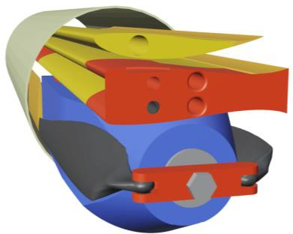

Folded Airplane

**Figure 2.1: Folded Airplane Inside Canister**

Callout Lines: black line (unless a different color offers a stronger contrast), no shape outline, ½ pt. weight

Insert → Shapes → Lines Category, select Line

Callout Text: black, Calibri, 10 pt. (callout text not enclosed by a box or other shape), last letter of callout text aligns with other callout text

Evidence can take on many forms, but tables and figures are one of the most common forms of evidence in technical writing. After presenting evidence, be sure to interpret it (also known as providing a line of reasoning). Because the three wing segments are stacked vertically in a confined space when folded, as illustrated in *Figure 2.1*, no dihedral, incidence, or aerodynamic twist was added to the airplane. There is just enough space for the three wings to be stacked in parallel to each other in the canister without any incidence or dihedral angles taking up more vertical space. Taper was not added since it would reduce wing area and lead to a higher than optimal wing loading.

* + 1. *Formatting Tables that Span More Than One-page*

Sometimes tables move from one page to the next. For tables split between two pages, repeat the table header on the second (and subsequent pages) (see *Table 2.2*).

**Table 2.2: Similitude Parameters and Values**

|  |  |  |  |  |
| --- | --- | --- | --- | --- |
| **Parameter** | **Units** | **Prototype** | **Ideal Model (1/7)** | **Model Design**  **Point (1/7)** |
| Characteristic Linear Dimension | ft | 7.50 | 1.07 | 1.04 |
| Reynolds Number | - | 9420000 | 450000 | 453000 |
| Mach Number | - | 0.179 | 0.068 | 0.070 |
| Froude Number | - | 165 | 165 | 167 |
| Relative Density Factor | - | 0.106 | 0.106 | 0.106 |
| Density | lb/ft3 | 85.2 | 85.2 | 84.7 |
| Cruise Speed | ft/s | 200.0 | 75.6 | 76.0 |
| Mass | lbs | 3800 | 11 | 11 |
| Linear Acceleration | ft/s2 | 0.369 | 0.369 | 0.637 |

|  |  |  |  |  |
| --- | --- | --- | --- | --- |
| **Parameter** | **Units** | **Prototype** | **Ideal Model (1/7)** | **Model Design**  **Point (1/7)** |
| Volume | ft3 | 44.50 | 0.13 | 0.13 |
| Thrust | lbf | 1400 | 4.08 | 7.00 |
| Endurance | hrs | 2.00 | 0.75 | 0.68 |

As *Table 2.2* illustrates, it is not necessary to repeat the table label on the second (and subsequent pages).

When introducing and interpreting a figure, avoid using the words *below* and *above* to orient your reader to a figure or table. Instead, refer to the graphic by graphic type and number (i.e., *Figure #* or *Table #*).

Additionally, the alignment of content in the column must match the alignment of the column header. In *Table 2.2*, the content of the first column is left-aligned because the content is text-centric. Consequently, the column heading is also left-aligned. The content in the other four columns is more number centric; therefore, the columns and column headers are centered.

* + 1. *Avoiding the Stacking of Graphics*

Whenever a graphic is used, you must incorporate the three “I’s” for each graphic, being careful not to mass introduce a series of graphics, or to stack multiple figures and/or tables in a data dump. However, it is sometimes beneficial to compare graphics side-by-side. In these situations, and to avoid stacking figures, *Figure 2.2* illustrates how to present more than one graphic at a time.

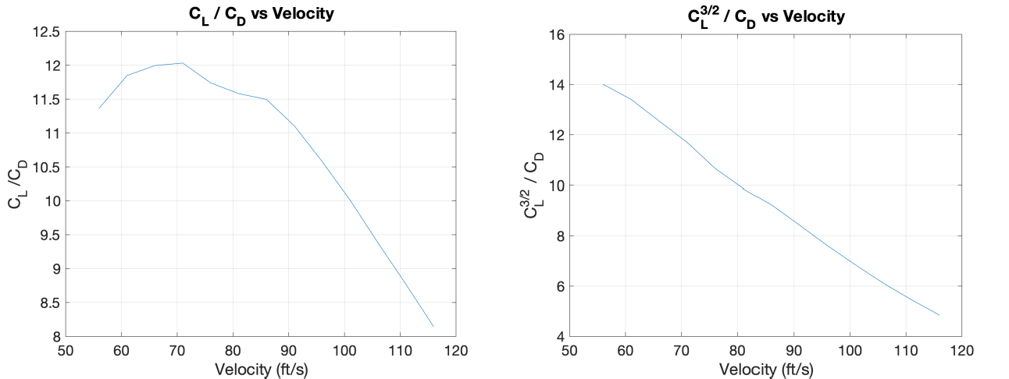

**Figure 2.2: Full Aircraft Range and Endurance Parameters**

The interpretation of a figure that presents more than one graphic as a single figure would emphasize takeaways from the leftmost image and takeaways from the rightmost image. Another strategy involves labeling each image with a letter (i.e., A. and B.) that would then be referenced as you interpreted each figure.

* + 1. *Adding Text to Graphics*

While it is true that a picture is worth a thousand words, pictures do not replace words. Instead, they work together to help your audience visualize and quickly understand information. Words are essential for adding context, interpretting graphics, and connecting the dots for the reader.

Sometimes, especially for graphics with a lot going on, callout arrows can quickly orient a reader to specific features of a visual (see *Fig. 2.1*, p. 4). Other times, text overlaid on top of a graphic offers essential information for an audience to understand what they are looking at in a figure (see *Fig. 2.3*).

Text inside graphics (labels, callouts, or other text), Calibri, 9-10 pt., left aligned or center aligned

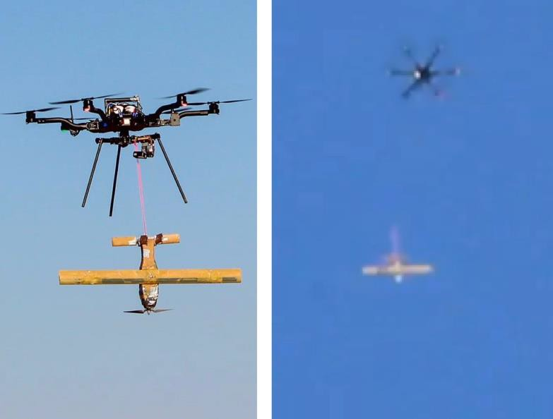

Hexcopter at

6500’ AGL

Fixed wing model

tethered to hexcopter

Fixed wing model falling

away from hexcopter

Use the text box feature for adding text to graphics. Select “No Fill” and “No Outline”

**Figure 2.3: Deployment System for Flying Fish Aircraft**

As illustrated in the leftmost image of *Figure 2.3*, the hexcopter transported the fixed wing model of the Flying Fish from the ground to a release height of 650 ft (right image)1.

* + 1. *How to Cite Borrowed Graphics*

Borrowed images are cited the same way borrowed text is cited. If the borrowed source is committed to archiving (e.g., journals; books; newspapers; conference proceedings; some company websites like NASA or JPL, for instance; and electronic databases), then insert an in- text AIAA citation at the end of the figure or table label (see *Fig. 2.4* for an example).

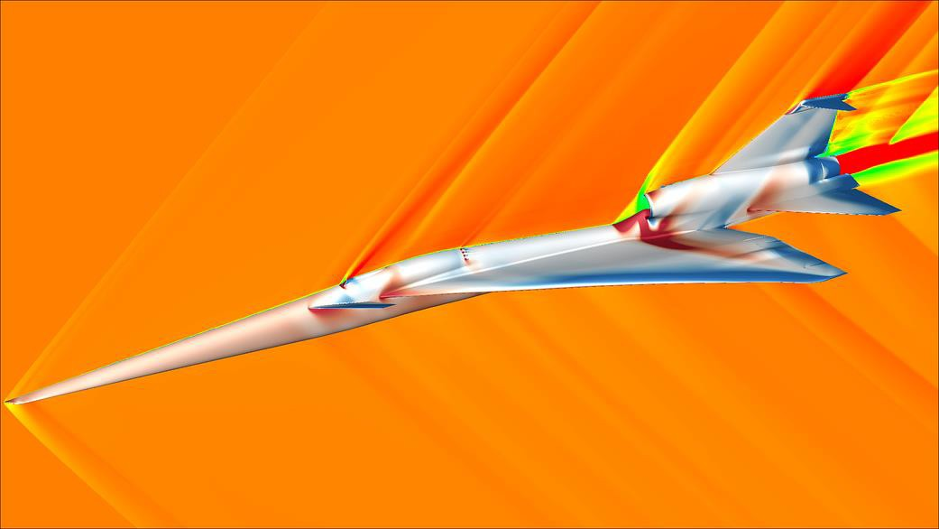**Figure 2.4: Visualizing Quieter Supersonic Flight** [3]

AIAA in-text citation is added at the end of figure label, not bolded

1 Due to the 650 ft altitude and the team’s lack of a quality camera with a telephoto lens, the image quality of the rightmost image is of poor quality, but still provides visual data important to the project. Use footnotes to communicate ancillary information not critical to your argument. Calibri Light, 10 pt., black

It is clear, from *Figure 2.4* that NASA’s X-59 Quiet Supersonic Technology demonstrates maecenas porttitor congue massa. Fusce posuere, magna sed pulvinar ultricies, purus lectus malesuada libero, sit amet commodo magna eros quis urna. Nunc viverra imperdiet enim. If the borrowed source is not committed to archiving (e.g., most websites; classified or export- restricted references; and private communications like personal interviews, emails, or text messages), the source is cited using a footnote (see *Fig. 2.5*).

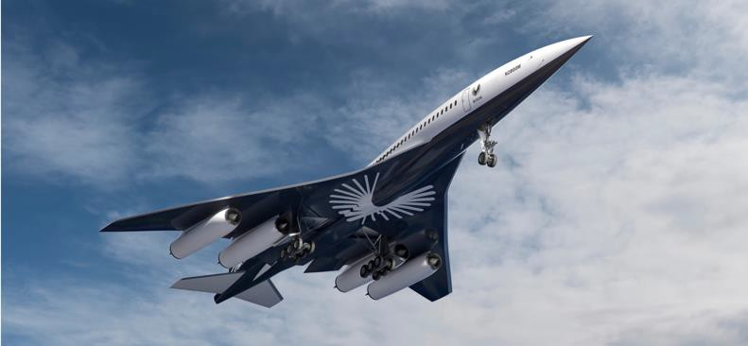

**Figure 2.5: Boom’s Overture Supersonic Passenger Jet**2

AIAA footnote citation is added at the end of figure label, not bolded

Footnote: Author Surname(s), First Initial. ‘Title’ Available: http:// website-url

If author is a company, replace surname with company name.

The supersonic jet pictured in *Figure 2.5* represents Boom’s vision of the future of transoceanic flight. With a cruise speed of Mach 1.7 and a cruising altitude of 60,000 ft, the Overture is two times faster over water than conventional (non-supersonic) passenger planes. Additionally, total flight times are drastically cut with supersonic jets. Current flight times from New York to Frankfurt are 8 hours and 14 ½ hours for travel from Los Angeles to Sidney. The Boom Overture cuts these travel times nearly in half—4 hours 15 minutes from New York to Frankfurt and 8 hours 30 minutes from Los Angeles to Sidney2. In addition to time savings, the Overture boasts other benefits including:

* Net zero carbon operation
* Chapter 14 noise levels
* Passively cooled turbine
* 100% SAF compatible
* Increased fuel efficiency
* 4250 NM range

A bulleted list is always introduced and set off with a colon (:); list is single-spaced and does not include ending punctuation; it is written in sentence fragments; a full 12 pt. line of space is inserted after list (no line of space preceding list); the text following bulleted list expounds on information found in list; location of bullet in relation to margin and start of bulleted text is defined here:

* Passenger capacity, 65-80

**Left Margin**

**Bullet**

**Bulleted**

**Text**

Pellentesque habitant morbi tristique senectus et netus et malesuada fames ac turpis egestas. Proin pharetra nonummy pede. Mauris et orci. Aenean nec lorem. In porttitor. Donec laoreet nonummy augue.



# TECHNICAL WRITING EXPECTATIONS

Among the fundamental objectives of technical writing are the tasks of making information quickly accessible to a reader and ensuring that your documents cannot be misunderstood—both of which are often easier said than done. To meet these objectives, successful technical communicators employ five strategies to help readers clearly and efficiently navigate a document.

2 Boom. ‘The Symphony Engine’ Available: https://boomsupersonic.com Example of footnote citation

## Address Audience Needs and Establish Credibility

Awareness to audience is critical in any type of writing, but more so in technical writing as the audience’s familiarity with the subject determines how detailed and technical your document needs to be. Carefully crafting your argument for a particular audience not only improves your ability to communicate information that cannot be misunderstood, but it helps to establish your credibility as someone who knows what they are talking about.

* + 1. *The Rhetorical Pyramid*

Audience awareness requires technical writers to consider author, audience, purpose, and context. Consider all aspects of the rhetorical pyramid in the planning, researching, composing, revising, and publishing processes (see *Fig. 3.1*).

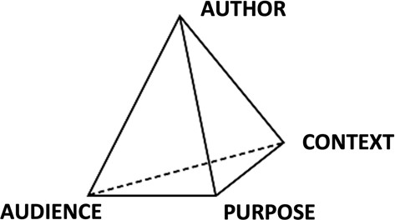

**Figure 3.1: Rhetorical Pyramid**

Each of the four points of the pyramid requires intentional practices that help to establish credibility and document clarity. The *author* point requires you to consider and employ strategies that establish author credibility (i.e., performing research from trusted and reliable sources, taking the time to double check citations, double checking math in tables, editing your document, and so forth). The *audience* point of the pyramid indicates that awareness of audience is obvious—writing appropriately addresses a mixed audience (technical experts and lay readers). Additionally, terms and abbreviations are clearly defined, assumptions are clearly stated, and information is adequately detailed. The *purpose* point invites you to consider the intended purposes of the document. Writers of documents address an audience for a specific reason or purpose. When you identify what you want from a reader, you can develop the necessary strategies to get what you want. Once you know the purpose, be sure to compose and format your document accordingly3. The *context* point considers where, when, and how the document will be used. Think about the following:

* + - * How will your audience use the information you present?
      * What is the physical context for how the document will be used (i.e., requested deliverable, meeting, conference, presentation)?
        + What adjustments will be needed to make the document more readable or the information more accessible in these situations?
      * What prior events, relationships, or past experiences need to be considered in preparing your document?

3 Some of the most common motivations for drafting a document include: analyze, assess, conclude, convince, develop, devise, determine, educate, examine, explore, expose, formulate, generate, inspect, investigate, propose, recommend, report, resolve, sell, and study.

The answers to these questions play an important role in how you write and present/format your document.

* + 1. *Citing Borrowed Information*

All borrowed information (direct quotes, summaries, and paraphrased content) must be cited using AIAA (or IEEE for robotics) for both in-text citations and references (see section 5.0). Additionally, all borrowed information uses the three I’s whenever appropriate (introduce, insert, and interpret)—avoid data dumping borrowed information (prose and graphics).

* 1. **Format with a Focus on Document Design, Readability, and Accessibility** The formatting of all documents considers HATS and CARBS elements. HATS stands for headings, art, typography, and spacing; and is used to enhance the visual appeal of a document. CARBS stands for contrast, alignment, repetition, balance, and spacing; and is used when designing visual aids (tables and figures). Like borrowed information, all art (figures and tables) incorporates the three I’s (see section 2.3). Make sure interpretations of art correspond with what is shown in a figure or table.

Additionally, graphics are visually clear, easy to read, and whenever possible adhere to the five- second standard—the reader should be able to understand the general gist of a figure or table within five seconds or less.

## Impose Order through Revision

Six strategies should be employed to impose order in any document, including:

* A clear hierarchy of headings has been established (see section 1.0).
* Transitional words and phrases4 within and between paragraphs are employed to effectively move the audience from one idea or concept to the next.
* Parallel structure is employed wherever appropriate.
* Affectation (e.g. buzzwords, jargon, and gobbledygook) is avoided.
* Telegraphic style is avoided to reduce the risk of ambiguity and misunderstanding.
* Paragraph length is appropriate for audience and purpose.

If you don’t know what some of these strategies mean, reach out to your technical writing professor for clarification.

## Revise and Edit the Document

Revision and editing, though related, are not the same. Revision (re + vision) requires a rethinking of the document and usually involves deleting text, moving blocks of writing, rewriting sections, and merging information. Revision can be compared to a kitchen remodel that has you moving the location of the sink, tearing out cabinets, adding an island, and rethinking the overall design of the space. Whereas revision is a remodeling of your document, editing looks at

4 Excellent resource for using transitional words and phrases: Pellegrino, V. C., *A Writer’s Guide to Transitional*

*Words and Expressions*, Maui arThoughts Company, Wailuku, 2009.

the finer details of your document (i.e., mechanics5, punctuation6, grammar7, and parts of speech8). Revision and editing require an investment of time and ensure that writing is clear throughout the document.

## Provide Technical Descriptions Focused on Clarity and Precision

To improve clarity and to achieve *sound technical writing* (as described by Beck, McElwain and Helbling), include accurate, precise, detailed descriptions of all systems, subsystems, procedures, and processes, describing the whole system first and then addressing specific subsystems.

# PRESENTATION SLIDE DECK



Title slides include title of presentation, date of presentation, and presenter(s) of presentation (for team presentations, simply include team name and logo. A graphic related to presentation topic can also be added to title slide. Slide number does not appear on title slide.

5 E.g., abbreviations, acronyms, capitalization, numbers, spelling

6 E.g., commas, dashes, hyphens, parentheses, colons, semicolons

7 E.g., subject-verb agreement, verb tense, voice, usage

8 E.g., adjectives, adverbs, articles, nouns, verbs

slide title: left aligned at top of slide

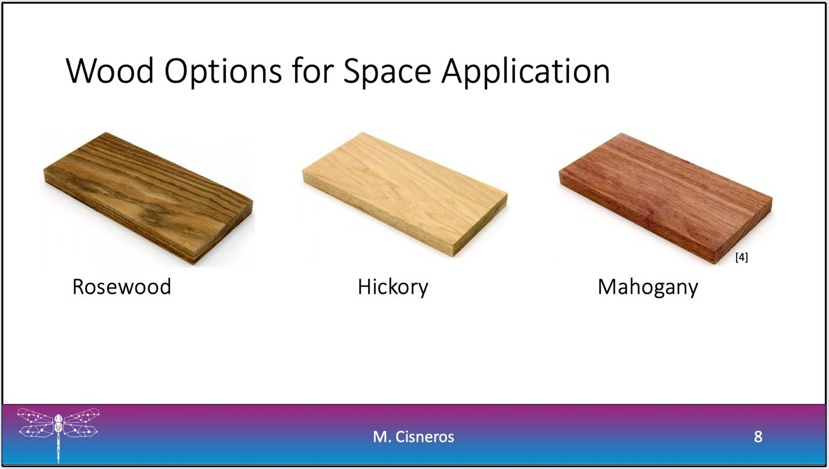

labeled graphics in non-italic font without “Figure” label

for borrowed images, an AIAA in-text citation appears as a bracketed number

white background (dark backgrounds pose readability issues from a distance)

first initial and last name of person presenting slide appears in footer, min. font size 20 pt.

slide number appears in footer, min. font size 20 pt.

Use a sans serif font (Calibri, Helvetica, or Arial) for text appearing in slide decks (exception: equations may employ serif font).

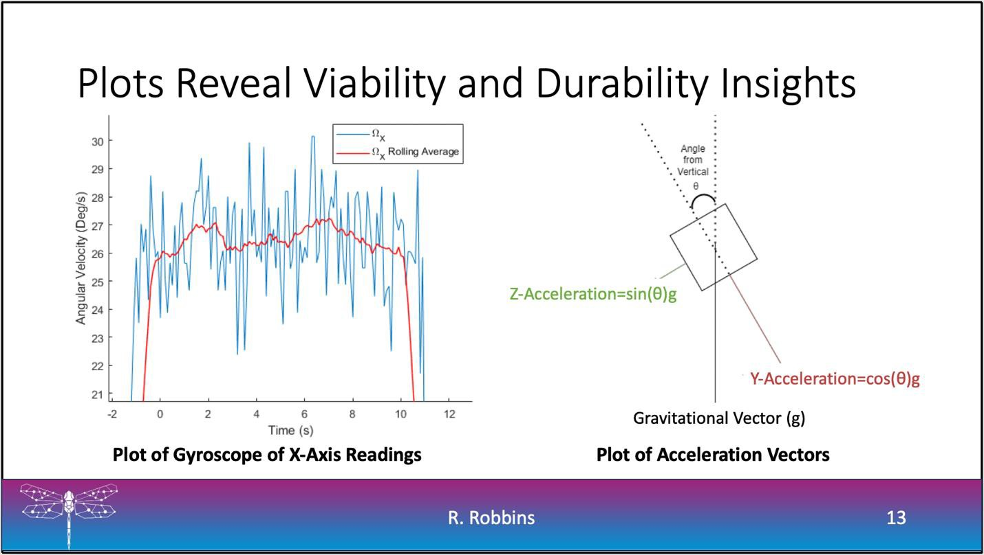

Informative slide titles address the “so what?”

callout arrows, when used, offer a strong contrast (are easily visible); callout text block has no outline or fill color

# REFERENCES

Unlike previous A-level sections found in your document, A-level headings found in the document’s back matter start on a new page. All references formatted according AIAA citation guidelines (or IEEE for robotics)

[1] Beck, A., McElwain, P., and Helbling, J., *Style Manual of the College of Engineering*, 3.5 ed., ERAU, Prescott.

References that appear on the References page must be limited to readily accessible published material; i.e., those available from libraries, databases, and other public sources. All references must be numbered and cited in numerical order in the text. The list should be a complete and comprehensive representation of available literature, reflecting the state of the art as it pertains to the scope of the paper. Authors must reference the original source of a work, not a secondary source.

Classified or export-restricted references, private communications, personal websites, and websites where there is no commitment to archiving [should] be mentioned [. . .] in a footnote but should not be cited in the reference list. A reference that is not reliably available is of no use to readers.

The following information is borrowed from https:/[/www.aiaa.or](http://www.aiaa.org/publications/journals/)g[/publications/journals/](http://www.aiaa.org/publications/journals/) reference-style-and-format

## In-text Citations

Each numbered reference citation in the text is enclosed in brackets as illustrated in the following examples:

It is shown by Smith [4] that . . .

The effect of . . . should be taken into account [5]. For example, see Refs. [6, 7].

Further documentation can be found in [8-10].

When a specific page number or page range needs to accompany a citation within the text, include it within the brackets in the following manner:

This procedure was proposed by Gelb [11, p. 250] The solution can be found in Rogers [12, pp.14-18].

When multiple author names are cited in the text, list up to two authors, as in “Walsh and Jones,” but use “et al.” with three or more authors, as in “Walsh et al.”

## List of References

The following list gives examples of information commonly missing from reference citations:

* + - All authors to a reference (do not use “et al.” in the reference list)
    - Full journal or book titles and publisher names (no abbreviations)
    - Inclusive page numbers for journal articles and page or chapter numbers for books
    - Journal volume and issue numbers (or months)
    - Locations of report sponsors (e.g., companies and universities)
    - Complete publishing information for proceedings (i.e., the same as for other books)

For *all* references: Spell out *everything* except AIAA, NASA, NACA, AGARD, and NATO; months may be abbreviated. Follow these examples for format:

*Chapter in a Book*

1. Turner, M. J., Martin, H. C., and Leible, R. C., “Further Development and Applications of Stiffness Method,” *Matrix Methods of Structural Analysis*, 1st ed., Vol. 1, Wiley, New York, 1963, pp. 6–10.

*Journal Article*

1. Johnson, J. E., Lewis, M. J., and Starkey, R. P., “Multi-Objective Optimization of Earth- Entry Vehicle Heat Shields,” *Journal of Spacecraft and Rockets*, Vol. 49, No. 1, 2012, pp. 38–

50. [Note: Month acceptable if number is not available.]

*Journal Article Not Yet Published*

1. Devasia, S., and Lee, A., “Scalable Low-Cost Unmanned-Aerial-Vehicle Traffic Network,” *Journal of Air Transportation* (not yet published).

*Proceedings/Transactions Articles*

1. Blottner, F. G., “Prediction of Electron Density in the Boundary Layer of Entry Vehicles with Ablation,” *The Entry Plasma Sheath and Its Effects on Space Vehicle Electromagnetic Systems*, NASA SP-252, Vol. 1, Oct. 1970, pp. 219–240.
2. Wirin, W. B., “Space Debris 1989,” *Proceedings of the Thirty-Second Colloquium on the Law of Outer Space*, AIAA, Washington, DC, 1990, pp. 184–196.

*Company or NASA Report*

1. Bhutta, B. A., and Lewis, C. H., “PNS Predictions of External/Internal Hypersonic Flows for NASP Propulsion Applications,” VRA, Inc., VRA-TR-90-01, Blacksburg, VA, June 1990.
2. Miner, E. W., and Lewis, C. H., “Hypersonic Ionizing Air Viscous Shock-Layer Flows over Nonanalytic Blunt Bodies,” NASA CR-2550, May 1975.

*Meeting Paper*

1. Neifeld, A., and Ewert, R., “Jet Mixing Noise from Single Stream Jets using Stochastic Source Modeling,” AIAA Paper 2011-2700, June 2011.

*Electronic Databases*

1. Tseng, K., “Nonlinear Green’s Function Method for Transonic Potential Flow,” Ph.D. Dissertation, Aeronautics and Astronautics Dept., Boston Univ., Boston, MA, 1983, ProQuest Ebrary.

# ACKNOWLEDGEMENTS

It is a professional courtesy to thanks the individuals who funded and assisted you in your project (think of URI, the College of Engineering, your course professors, professors outside the course who you consulted, AXFAB machinists, industry professionals, etc.). Be sure to give credit where credit is due.

# ATTRIBUTIONS

|  |  |
| --- | --- |
| **Contributor** | **Contribution** |
| Name | Researched XYZ; Wrote, formatted, and revised Section 2.0 and 3.1; Edited  Section 1.0 and 6.0 |
| Name |  |
| Name |  |
| Name |  |
| Name |  |

Attributions table should identify what parts each member of the team researched, wrote, formatted, revised, and edited. More information is better than vague references to the document.